MODULE 4 – INTRODUCTION TO DBMS

LAB EXERCISES

6. DROP Command
Lab 1.
Drop the publisher table from the database after verifying structure.
Ans.
Verify the table structure:
1. SELECT * FROM publishers;
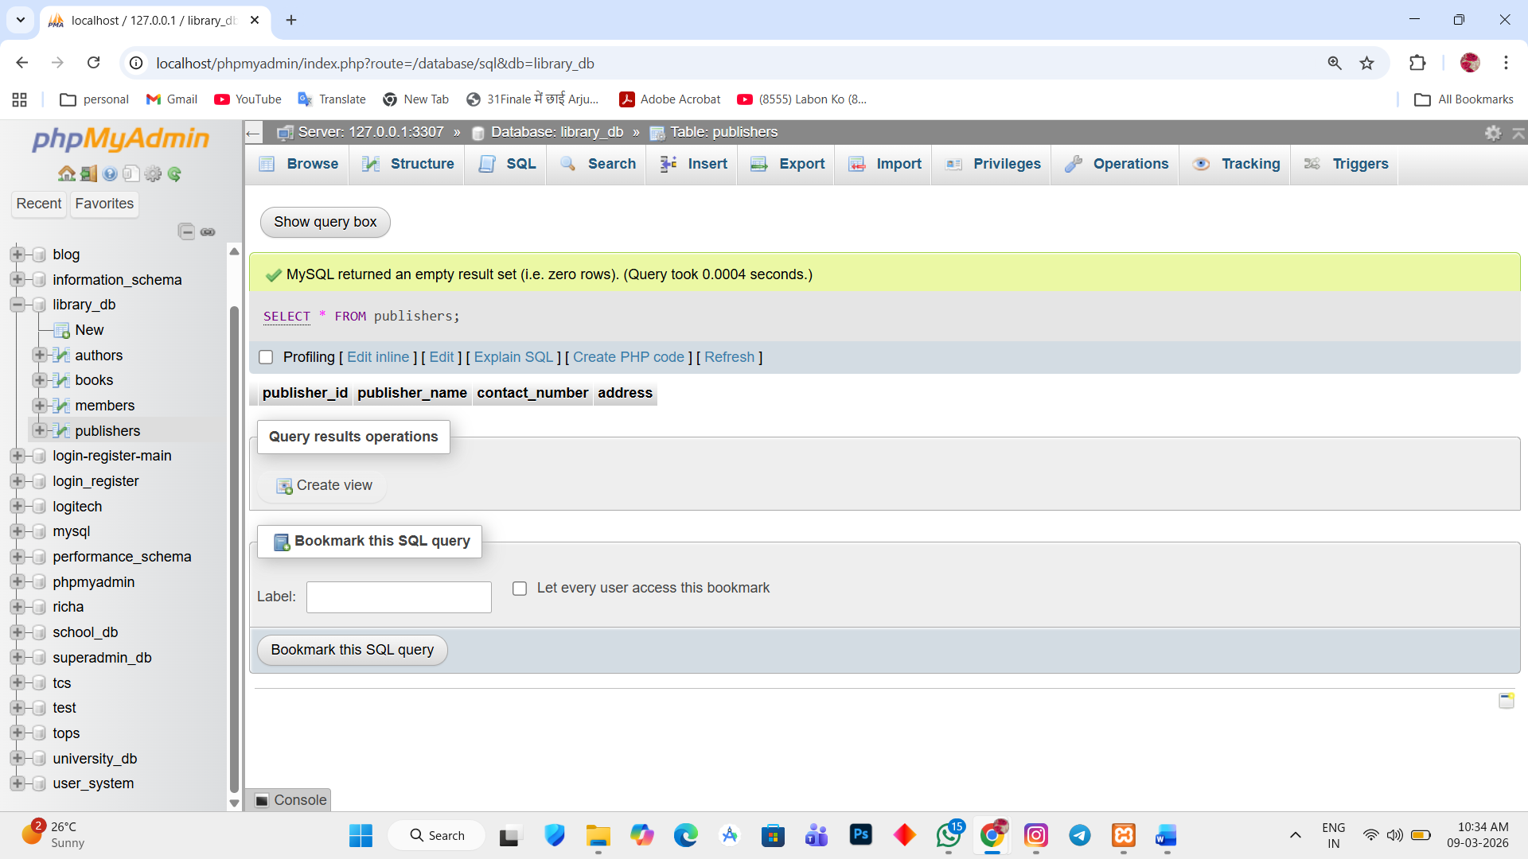

Drop the table:
2. DROP TABLE publishers;
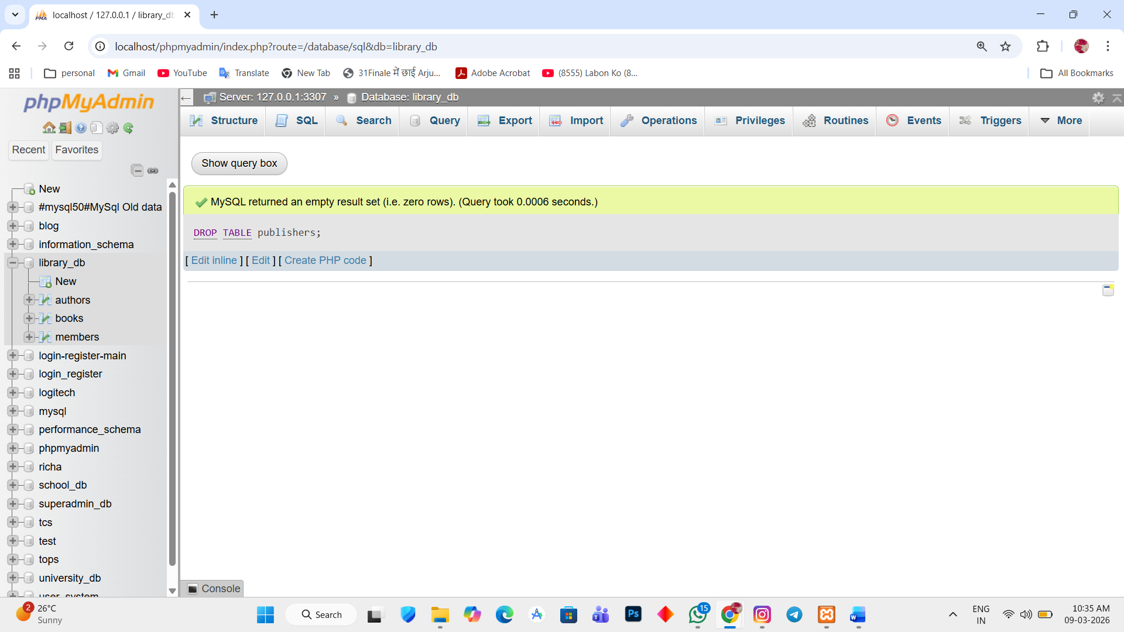

Lab 2.
Create a backup of the members table and then drop the original members table.
Ans.
Create backup of members table
1. CREATE TABLE members_backup AS SELECT * FROM members;
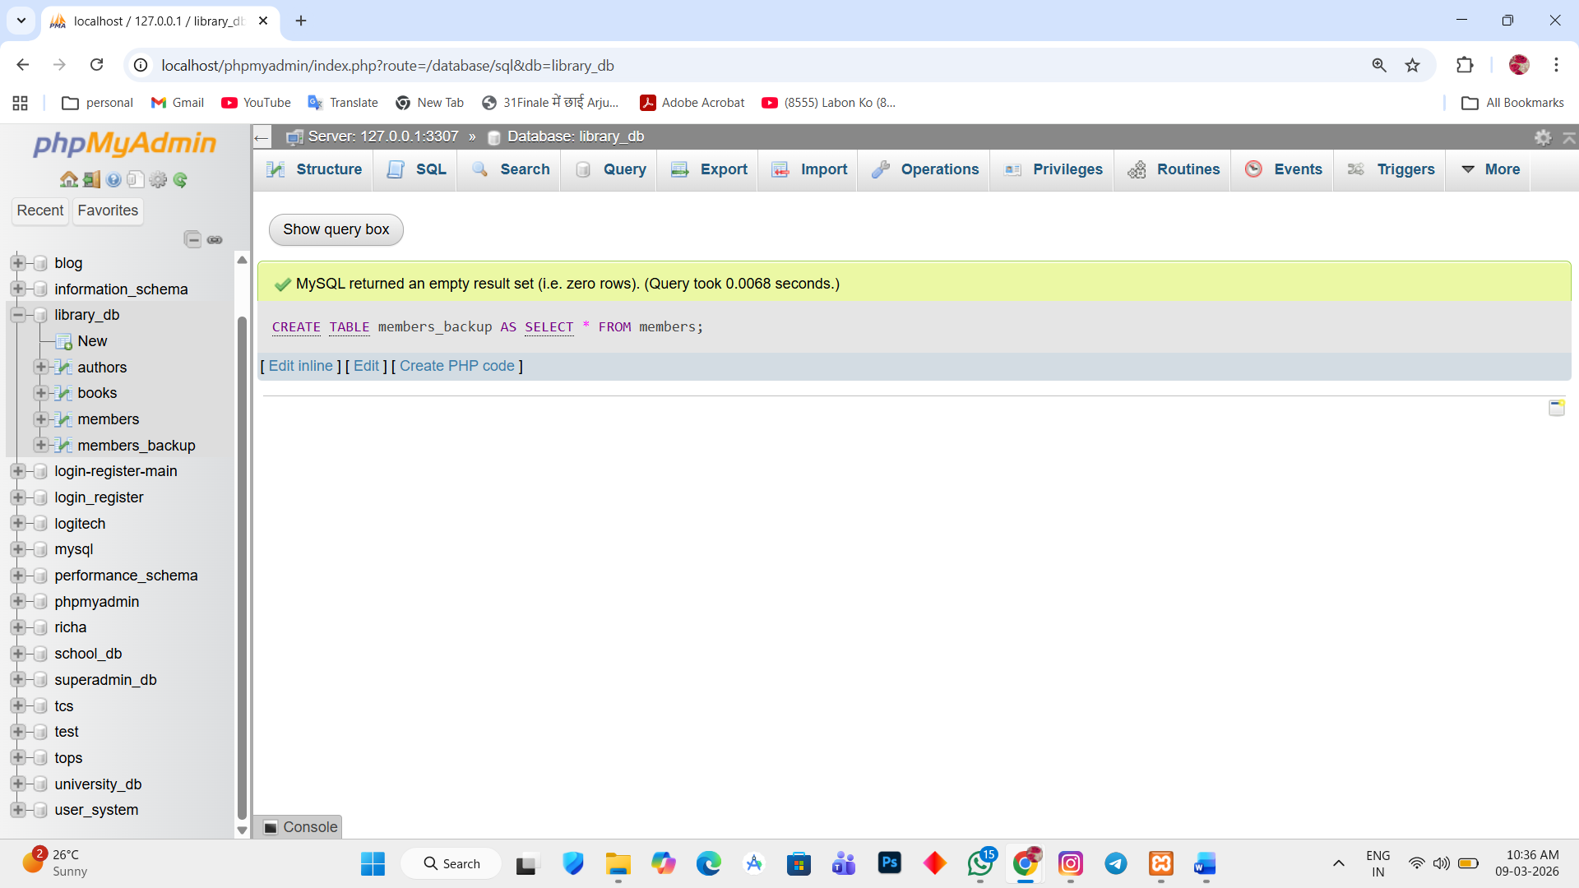

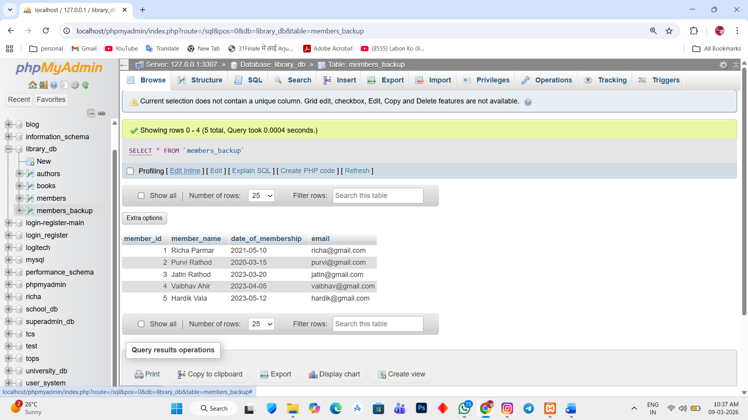

Drop the original members table
2. DROP TABLE members;
